Central Recordkeeping Agency

Standard Operating Procedure
on
Upload of Unequal – Employee & Government Contribution
for
Government Subscribers

Version 1.0
Acronyms and Abbreviations

The following acronyms and abbreviations have been used in this document:

ACRONYM | DESCRIPTION
CRA | Central Recordkeeping Agency
PFRDA | Pension Fund Regulatory and Development Authority
NPS | National Pension System
NSDL e-Gov | NSDL e-Governance Infrastructure Ltd.
PRAN | Permanent Retirement Account Number
CG | Central Government
SG | State Government
Pr.AO | Principal Accounts Office
PAO | Pay & Account Office
DTA | Directorate of Treasuries and Accounts
DTO | District Treasury Office
I-PIN | Internet - Personal Identification Number
PFMs | Pension Fund Mangers
NPSCAN | NPS Contribution Accounting Network
FPU | File Preparation Utility
FVU | File Validation Utility

Overview

The Government of India established Pension Fund Regulatory and Development Authority (PFRDA) on October 10, 2003 to develop and regulate the Pension Funds under the NPS. PFRDA has appointed NSDL e-Governance Infrastructure Ltd (NSDL e-Gov) as the Central Recordkeeping Agency (CRA) under NPS to maintain the records of contributions and its deployment in various pension fund schemes for the employees. PAO/DTO/DTA (hereafter referred as Uploading Office) provides the subscriber contribution details to CRA and remits the funds to Trustee Bank which in turn transfers the funds to Pension Fund Managers (PFMs) for investment. Units are allotted to the subscriber’s PRAN based on their contribution amount.

For Government subscribers, the Uploading Office uploads a Contribution file wherein the employee and employer contribution must be equal for each subscriber. This new functionality will allow the Uploading Office to upload unequal Employee Contribution and Government Contribution for its underlying subscribers. This document describes the Standard Operating Procedure to be followed by the Uploading Offices for upload of ‘Unequal Contributions’ for Government Subscribers under NPS.

There may be exceptional scenarios wherein the Uploading Office may require uploading contribution for its subscribers with unequal Employee and Government contribution i.e., the Employee contribution amount and Government’s contribution amount are not equal. In such cases, the Uploading Office may use this new functionally and upload the contribution file in the NPSCAN system. The functionality of uploading unequal contribution will be a two-step process (maker-checker) wherein an Uploading Office (e.g., PAO/DTO/DTA) is required to capture a request in the NPSCAN system and the Verifier is needed to authorise the same. In case of De-centralised & Quasi centralised model of contribution upload, the Oversight Office (i.e. PrAO/DTA) is required to authorise the request whereas in case of Centralised model of contribution upload, the request will be authorized by another User of the Uploading Office (i.e. another User of DTA). Once the request is authorised, the Uploading Office can create a Contribution file with unequal contribution amount (unequal employee and employer contribution) using the respective stand-alone utilities (FPU and FVU) and upload the file in the NPSCAN system.

Uploading Unequal Contribution – Process details

- Download of FPU & FVU
- Capturing of request for uploading unequal contribution in NPSCAN system
- Authorisation of request for uploading unequal contribution in NPSCAN system
- Request Status View for Unequal Contribution
- Preparation & Upload of SCF for unequal contribution in NPSCAN system

The detailed process for uploading Unequal Contribution for Govt. Subscribers is explained below:

- Download of FPU & FVU

To facilitate the Uploading Offices of Government Sector for uploading unequal contributions of its underlying subscribers, new File Preparation Utility (FPU) & new File Validation Utility (FVU) have been developed by CRA. The utilities can be freely downloaded from CRA website (www.npscra.nsdl.co.in). The minimum software & hardware requirement to install these new utilities as well installation procedure for new utilities will be similar to regular utilities being used for upload of contribution. Uploading Office shall download these utilities from CRA website and shall prepare Subscriber Contribution File (SCF) for unequal contribution using these utilities only. The Uploading Office shall consider only the unequal contributions while preparing the SCF so that these cases can be identified uniquely in future apart from regular contributions.

- Capturing of request for uploading unequal contribution in NPSCAN system (Maker Activity)

The Uploading Office of the Government sector (Maker) is required to login into the NPSCAN system (www.npscan-cra.com) using the User ID and password. Please refer Figure 1 below.

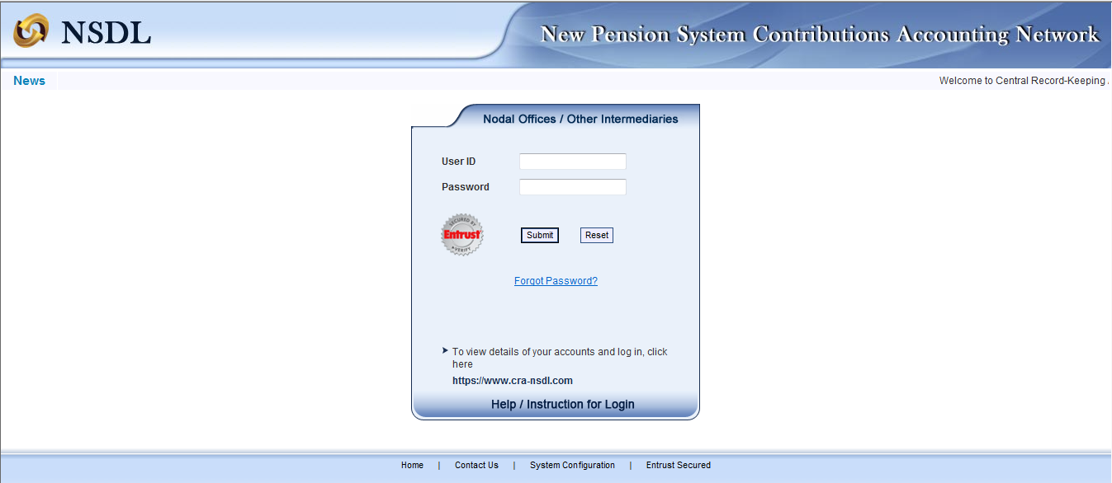
Figure 1

On successful login, the Maker is required to click the sub-menu ‘Request Creation for Unequal Contribution’ under the main menu ‘Contribution Details’ in order to capture request for uploading unequal contribution as shown in Figure 2 below.

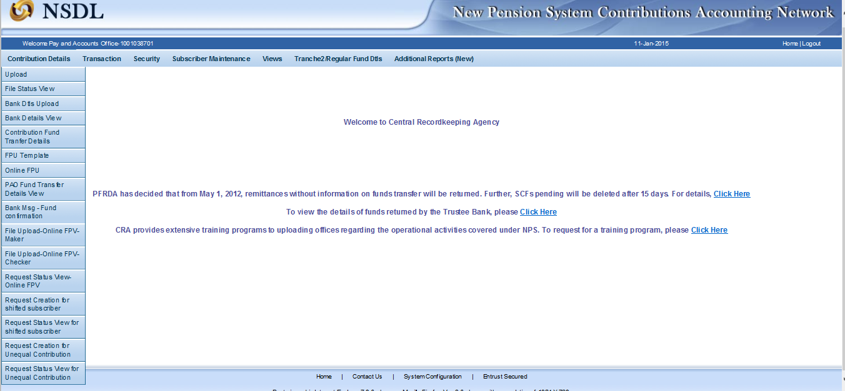
Figure 2

The Maker is required to enter ‘Requestor Remarks’ and click on submit. The User shall enter the proper reasons for the request so that these cases can be identified uniquely in future apart from regular contributions and the authorizer gathers an idea with the remarks mentioned by the Maker. Please refer Figure 3 below.

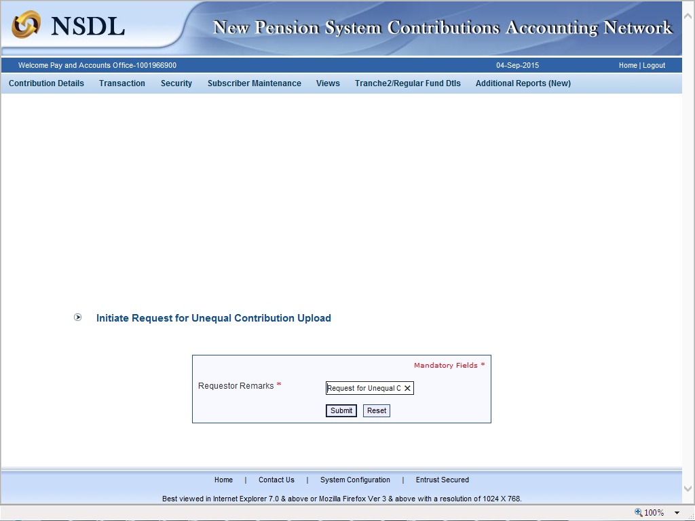
Figure 3
After submission of the request for Unequal Contribution, the request is accepted at NPSCAN with a confirmation message, ‘Request accepted at NPSCAN’ as shown in Figure 4 below.

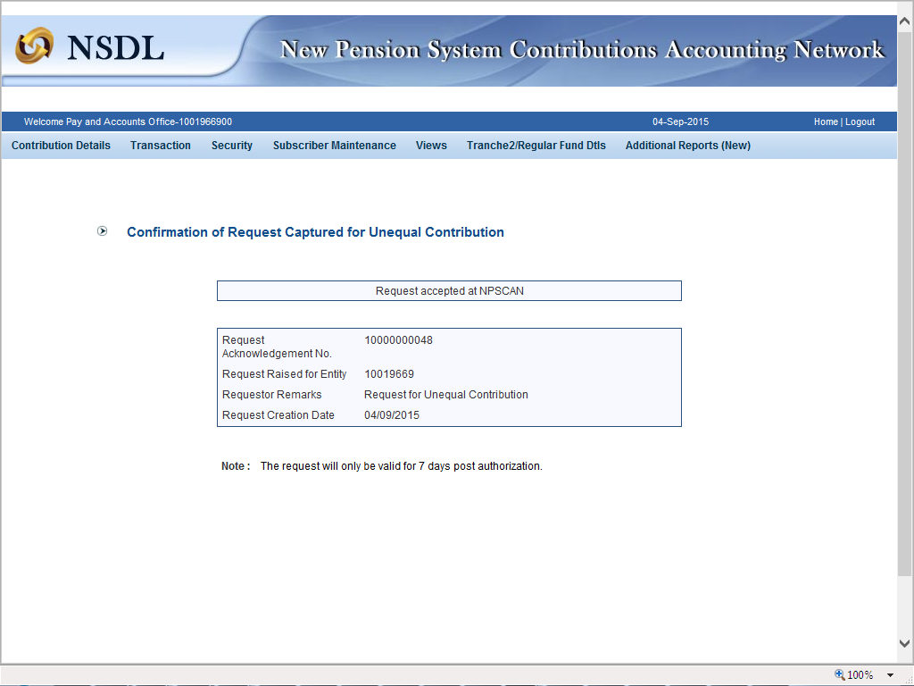
Figure 4

The system will also generate unique Acknowledgement Number for the request captured as shown in Figure 4 above. This Acknowledgement Number will enable the Uploading Office to check the status of the request.

- Authorisation of request for uploading unequal contribution in NPSCAN system (Checker Activity)

Once the request for unequal contribution is captured in the NPSCAN system, same needs to be authorized by the Authoriser. In case of De-centralised & Quasi centralised model of contribution upload, the Oversight Office (i.e. PrAO/DTA) is required to authorise the request whereas in case of Centralised model of contribution upload, the request will be authorized by another User of the Uploading Office (i.e. another User of DTA) only.

The Authoriser is required to login to the NPSCAN system (www.npscan-cra.com) with User ID and I-PIN. On successful login, the Authoriser shall click the sub-menu ‘Request Authorization for Unequal Contribution’ under the main menu ‘Contribution Details’ as shown in Figure 5 below to authorise the request.

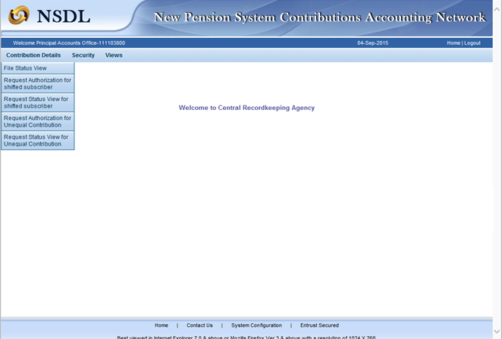
Figure 5

Once the Authoriser clicks the option ‘Request Authorization for Unequal Contribution’, the following screen will be displayed. Please refer Figure 6 below.

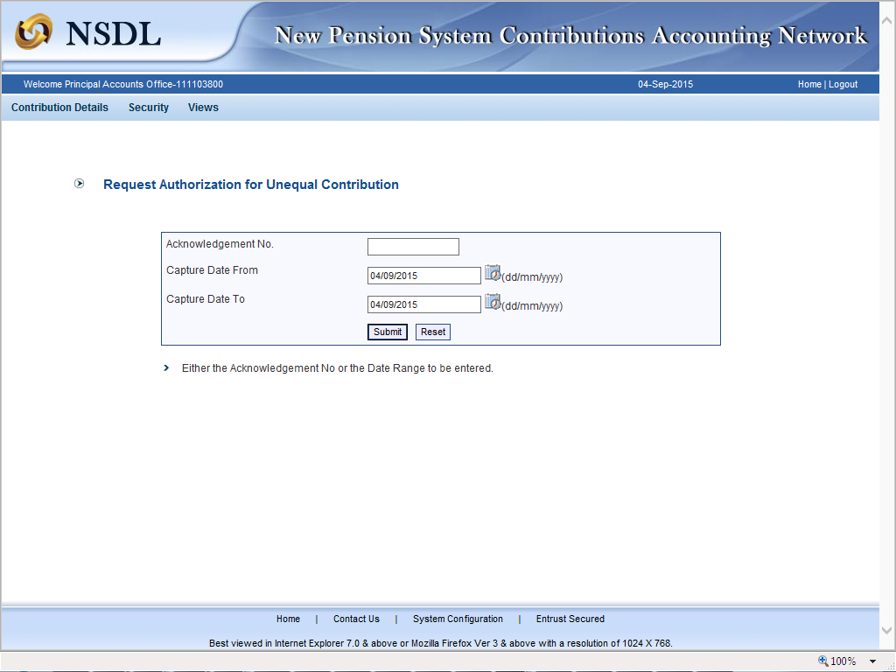
Figure 6
The Authoriser is required to provide either the ‘’Acknowledgement No.’’ and / or ‘’Request Capture date range (‘from’ and ‘to’ Date) and then click on 'Submit'. The screen with details of the request/s captured by the underlying User in NPSCAN system will be displayed as shown in Figure 7 below:

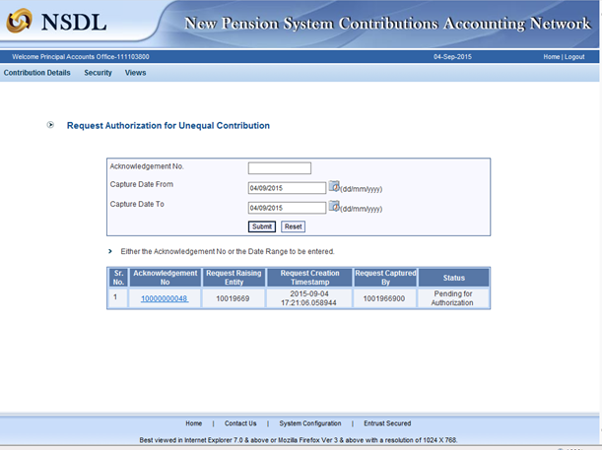
Figure 7

The Authoriser is then required to click on the hyperlink of the Acknowledgment No. to view the details of the captured request. Please refer Figure 7 above.

Once the User clicks on the aforesaid hyperlink, the confirmation screen for the Authoriser appears with an option to Authorise / Reject the request. The request will also display the details such as ‘Acknowledgement No’, ‘Created by’, ‘Entity Reg. No’, ‘Created timestamp’, ‘Remarks, and ‘Request Status’ as shown in Figure 8 below:

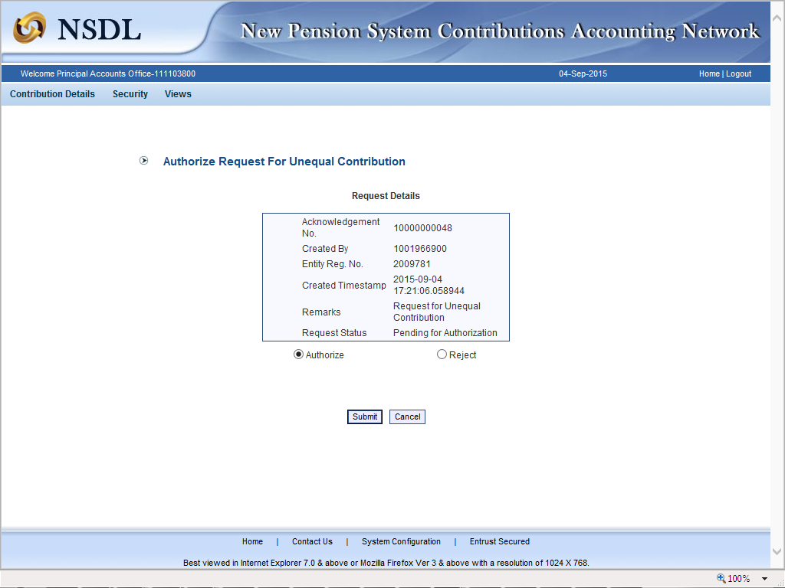Figure 8

The Authoriser is required to select ‘Authorise’ and click on 'Submit' the request. On authorization of the request, a confirmation message as shown in Figure 9 below will be displayed to the Authoriser.
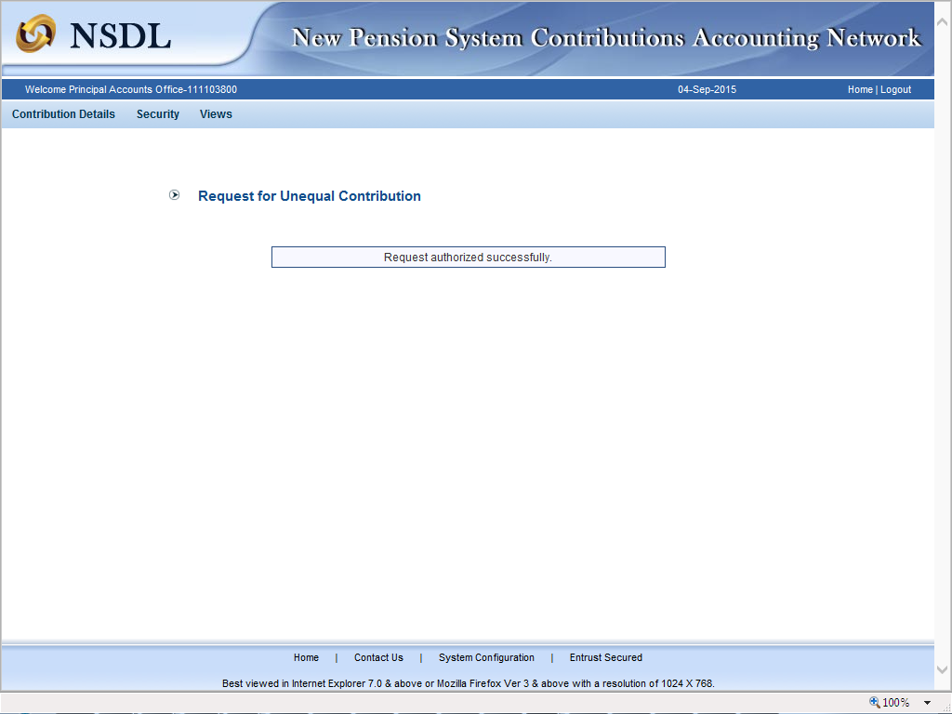
Figure 9
The Authoriser may however, reject the request (in case the request is incorrectly / incompletely captured) by selecting ‘Reject’ option, provide the ‘reason for rejection’ and ‘Submit’ as shown in Figure 10 below.

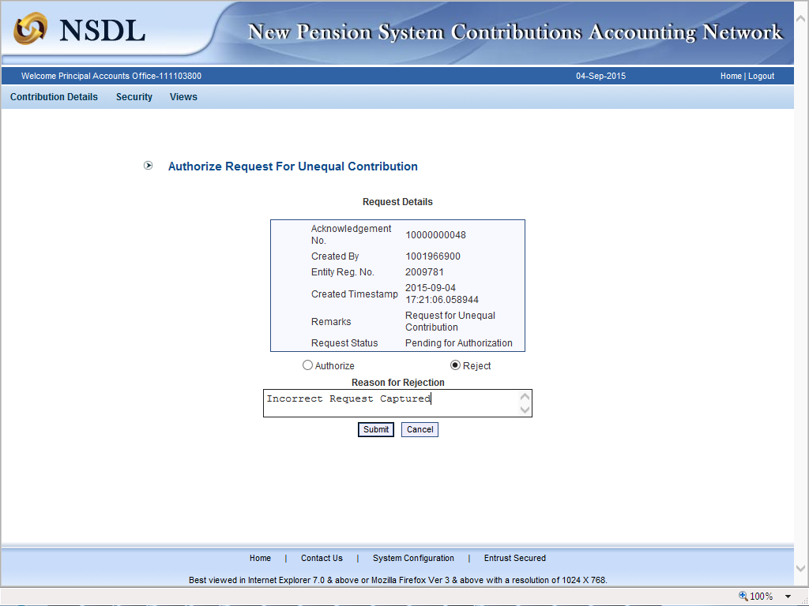
Figure 10
In case of rejection, the Maker (Uploading Office) is required to capture fresh request in NPSCAN system for upload of unequal contribution.

- Request Status View for Unequal Contribution

The Maker / Authoriser can check the status of any request captured in NPSCAN for unequal contribution. The User is required to select the option "Request Status View for Unequal Contribution" under the menu "Contribution Details". Please refer Figure 11 below:

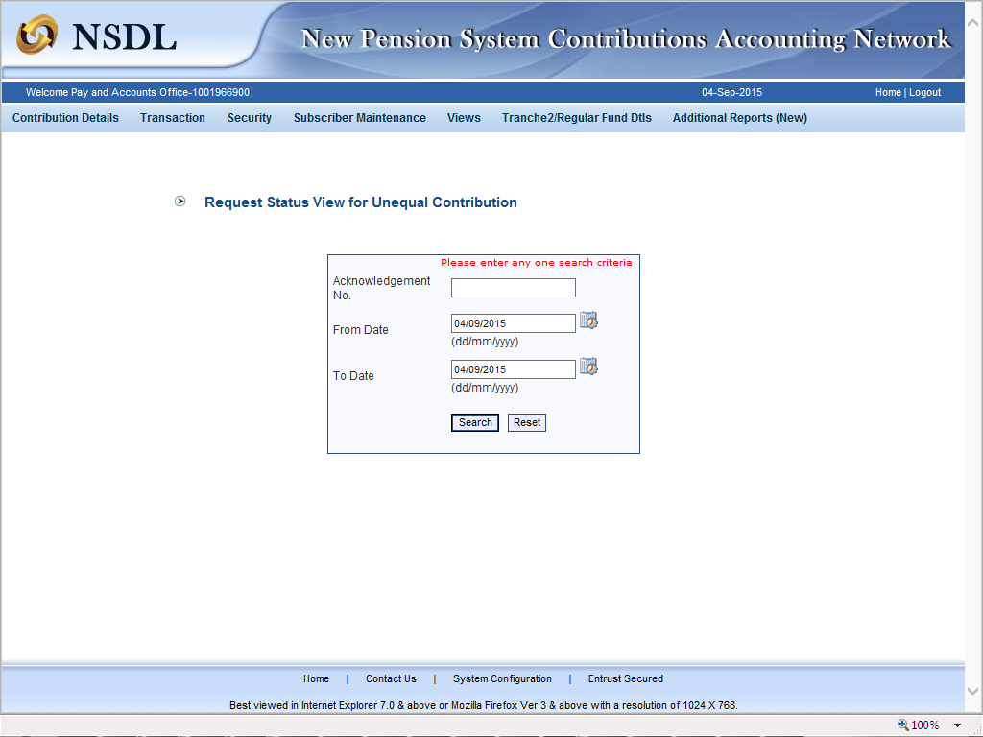
Figure 11

The User shall provide either the ‘Acknowledgement Number’ or ‘date range’ of the captured request. The system will display status of the captured request once User quests the request status through either of the aforesaid search criterias. Please refer Figure 12 below:

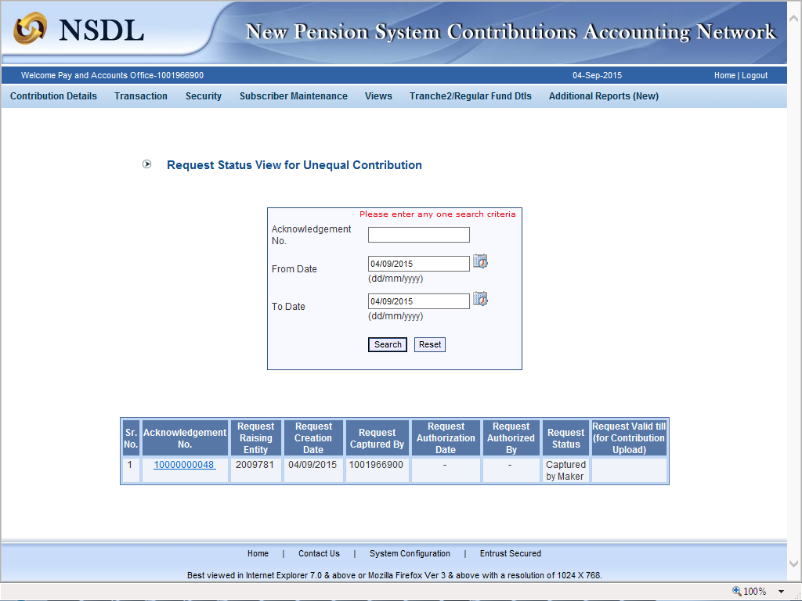
Figure 12
The present status of the file whether ‘Captured’, ’Accepted’ or ‘Rejected’ in NPSCAN system would be available to the User.

- Preparation & Upload of SCF for unequal contributions in NPSCAN system

Once the request for Unequal Contribution is authorised in the NPSCAN system, the Uploading Office can create a contribution file using the new File Preparation and Validation Utilities (FPU & FVU). The upload of contribution file in the NPSCAN system will be similar to the upload of regular contribution files. However, the upload of files for Unequal contributions is to be completed within a window period of seven days (after authorisation of the request). It may be noted that on expiry of the seven days, such files cannot be uploaded in the NPSCAN system and a new request is to be initiated by the Uploading Office for Upload of Unequal Contribution for Government subscribers.

-------------------------xxxxxx--------------------------

